**Welcome page:-** The page that comes automatically when we give first request to web application is called Welcome page/Home page.

Example:- when we give request to “https:// [www.gmail.com](http://www.gmail.com) “, we get log-in page of gmail application. This log-in page is called welcome page/home page.

* In Java web applications, the programmer can configure .html files, .jsp files, servlets as welcome files in “web.xml” file using <welcome-file-list>…</welcome-file-list> tag.

Syntax:

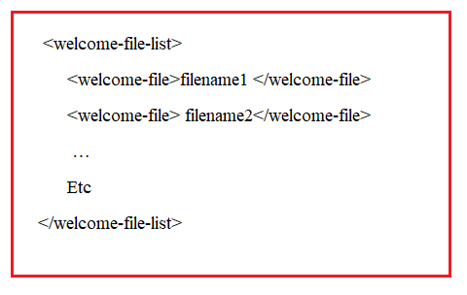

* If multiple files are configured as welcome files , then welcome file will be picked-up based on configuration order and configuration availability.

Example:-

If there, filename1 is not available then filename2 will be taken as welcome file.

If there filename1 and filename2 is also not available then filename3 will be taken as welcome file.

…etc.

IF no configured file is available then tomcat server will pick-up the either “index.html” or “index.jsp” as welcome file.

Note:-1. If index.html and index.jsp both are in web application then Tomcat ser will give more priority to index.html and index.html will be selected as

Welcome file.

Note2:- if index.html , index.jsp and configured files are not available then Tomcat server will display “404:File Not Found Error”.



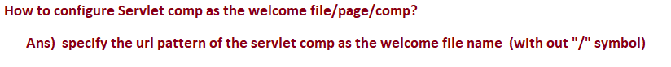

Example:-1

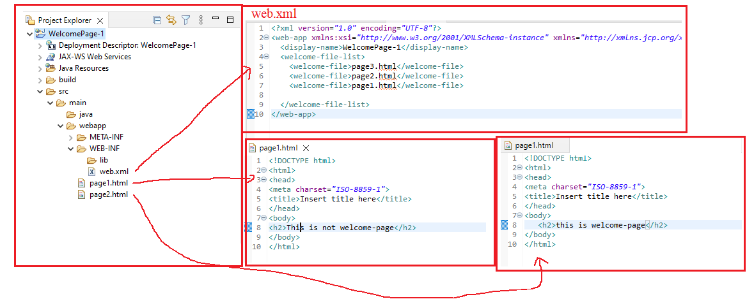

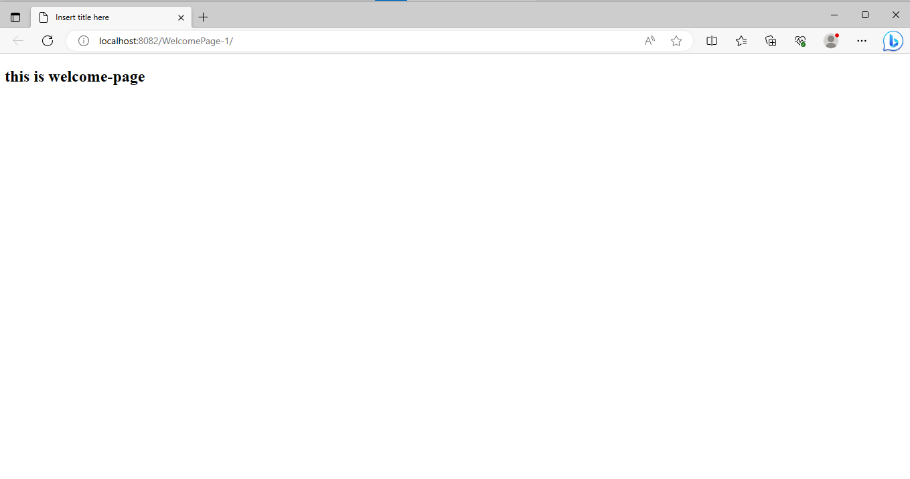

Example:2

